HR ANALYSIS REPORT

1. Write a query to find the name (first_name, last_name) and the salary of the employees who have a higher salary than the employee whose last_name='Kocchar’?

🡪 select first_name,last_name,salary from employee where salary > (select salary from employee where last_name

='kochhar');

1. Write a query to find the name (first_name, last_name) of all employees who works in the IT department?

🡪 select e.first_name, e.last_name from employee e join departments d on e.DEPARTMENT_ID = d.DEPARTMENT_ID where e.JOB_ID='IT_PROG' ;

1. Find the departments who are located in US?

🡪select d.department_name,l.country_id from departments d join location l on d.location_id = l.location_id where country_id = 'US';

1. Find the employees whoes department is located in US?

🡪 select e.first_name, e.last_name from employee e join departments d on e.DEPARTMENT_ID = d.DEPARTMENT_ID

join location l on d.LOCATION_ID = l.LOCATION_ID where l.country_id='US';

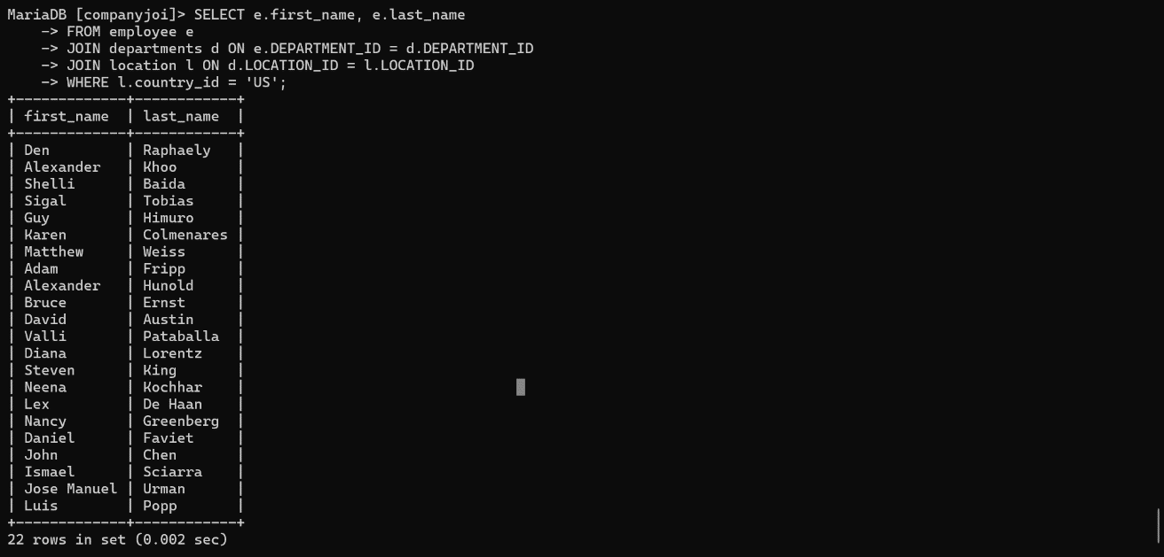

1. Write a query to find the name (first_name, last_name) of the employees who are managers?

* select e.first_name , e.last_name, d.manager_id from employee e join departments d on e.employee_id = d.manager_id;

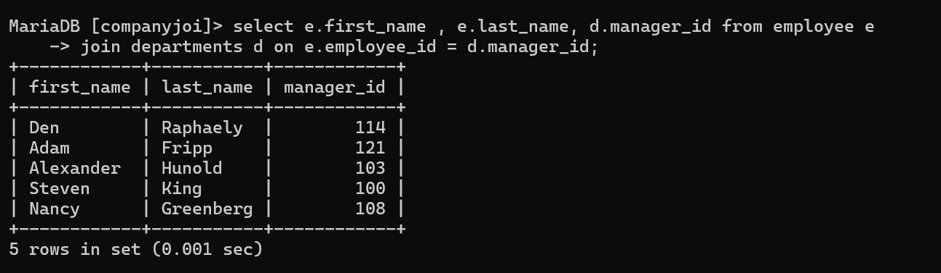

1. Write a query to find the name (first_name, last_name), and salary of the employees whose salary is greater than the average salary?

🡪 select first_name,last_name,salary from employee where salary > (select avg(salary) from employee);

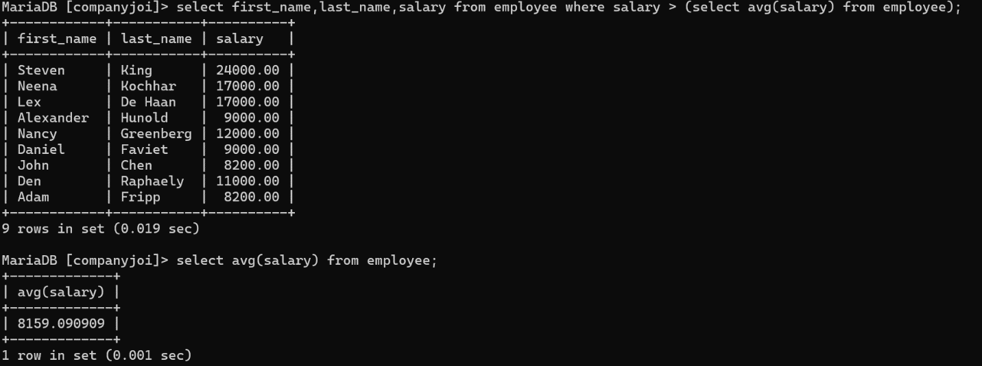

1. Write a query to find the name (first_name, last_name), and salary of the employees who earns more than the earning of Mr. Bell?

🡪 select first_name,last_name,salary from employee where salary > (select salary from employee where last_name='hunold');

